Computer Language Coding Concepts

Related Item
A system object manages an object’s relation to another object. A system object represents the internal workings of one object’s relation to another object.

You don’t usually see the internal workings. The related item is visible as the object itself. A related item is a system object.

A system object stores and manages a relation to another object. It does not manage the object itself, only the relation to another object.

A relation to another object is part of the parent object. A parent object is a real object. Its related item is not a real object, but a pointer to an object. The system interface of a related item determines which object the parent will refer to.

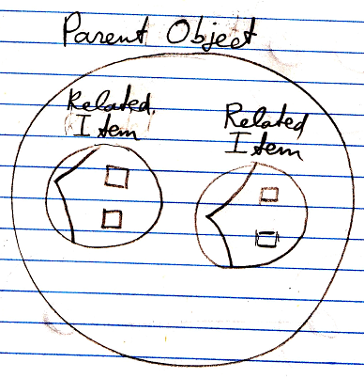

The pointers, so the system objects, are part of the parent object. Objects referred to by a parent object are not part of the parent object, but the references to the object are part of the parent object. Objects such as a related list or a related item are system objects that are inherently part of the parent object. Only the objects referred to are not part of the parent.

A related item is the result of a →1 relation.

Assignment and retrieval of the related item can be decorated with extra procedures. This is part of the control around a relation between a parent and its related item. A related item usually contains a related object. But a related item can also point to a →1 related item contained by another parent or point to a →n related list item contained by another parent. Such related object redirections are covered by the article Pointer to Pointer.

The related item system object is bound to the parent of the related item, not bound to the object itself. The parent object determines the target of related items, through the commands of the system object.

A related item, is yet another wrapper around an object reference.

A related item represents an object in relation to an another object.

The members of the system interface of a related item are:

Name
ID In Parent
Object . ID
Object . Get
Object . Set
Other Related Item . ID
Other Related Item . Get
Other Related Item . Set
Other Related List Item . ID
Other Related List Item . Get
Other Related List Item . Set
Value . Get
Value . Set
New
Annul
Created . Get
Created . Set

The complete interface of the related item system object looks like this in a diagram:

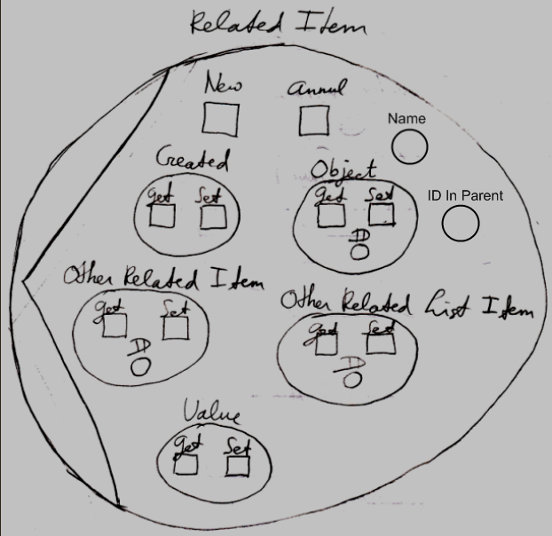

The members of the related item system object will be covered in the separate articles:

- Names of Related Items & Related Lists
- Related Items & Related Lists Collections
- New & Annul
- Object Get & Set
- Pointer To Pointer Get & Set
- Value Get & Set

The article Related Item mentions pointing not to a specific object, but to another →1 related item or →n related list item. That concept will be demonstrated with diagrams in the article Pointer to Pointer in a Diagram.

Decorating assignment and retrieval of a related item with extra procedures will be covered by the article Extending the System Interface.

See also: System Objects, New & Annul, Names of Related Items & Related Lists, Object Get & Set, Pointer To Pointer Get & Set, Value Get & Set, Pointer to Pointer in a Diagram, Extending the System Interface

Author & Copyright: Jan-Joost van Zon Date: July 18, 2008 – July 23, 2009 Location: Oosterhout, The Netherlands Status: Finished

